**Week 6:  Capstone Network Security Project**

**Objective:**  Simulate a secure network environment with monitoring and defense.

**Task#03:** **Set up a log monitoring system using Syslog-ng or Splunk Free version.**

**Solution:**

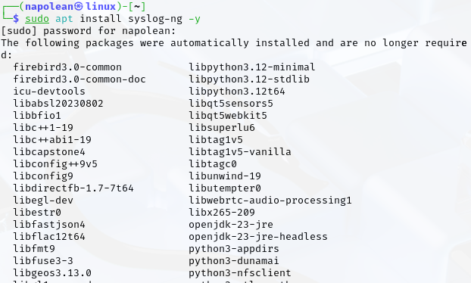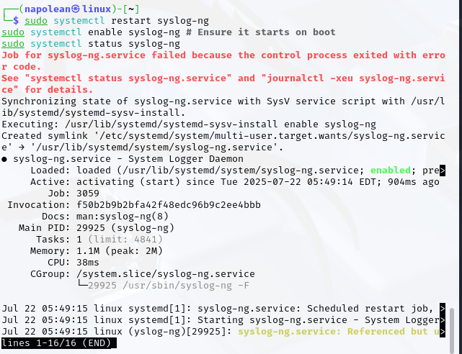

**Syslog** is a standard way for different computer systems and network devices (like routers, firewalls, servers) to send their event messages or "logs" to a central collection point. Think of it as a universal language for devices to report what's happening to a central "diary keeper." This allows administrators to gather all system activity in one place for monitoring, troubleshooting, and security analysis.